 | НАРОДНА УКРАЇНСЬКА АКАДЕМІЯ

НАВЧАЛЬНИЙ ПОСІБНИК З ПРАКТИЧНОГО КУРСУ
АНГЛІЙСЬКОЇ МОВИ

Для здобувачів вищої освіти 1 курсу
магістратури

Харків
Видавництво НУА
2025
УДК 811.111'36(072+075.8)
С 23

Затверджено на засіданні кафедри
германо-романської філології та перекладу
Народної української академії.
Протокол №9 від 05.05.2025

Автори-упорядники канд. філол. наук, доц. Л.В. Михайлова
викладач О.О. Мовчан
Рецензент канд. філол. наук М.Ф. Чемоданова

Н 15 | Навчальний посібник з практичного курсу англійської мови : для здобувачів вищої освіти 1 курсу магістратури / Нар. укр. акад, ; каф. германо-романської філології та перекладу ; авт.-упоряд. Л.В. Михайлова, О.О. Мовчан. – Харків : Вид-во НУА, 2025. – 54 с.

Навчальний посібник з практичного курсу англійської мови є важливим ресурсом для здобувачів вищої освіти 1 курсу магістратури, які вивчають англійську мову. Він пропонує ґрунтовний матеріал та художні тексти, що охоплюють географічні, політичні, економічні та соціальні аспекти англомовних країн, а також аналізує менталітет їхнього населення у взаємозв’язку з національно-специфічними реаліями. Посібник має чітку структурованість: матеріал подано відповідно до програми курсу, що забезпечує логічну послідовність викладу та практичну спрямованість.

TEXT 1
America's Amish communities live a lifestyle that has changed little since the 18th century; but in other respects, they are showing other Americans the way forward in the twenty-first....
The road sign is, to say the least, unexpected; driving through a prosperous rural part of North America, the last thing you expect to see beside the highway is a yellow diamond road sign with a horse and buggy in the middle! Watch out for horses and buggies on the road? What is this? Do they exercise racehorses here, or what?
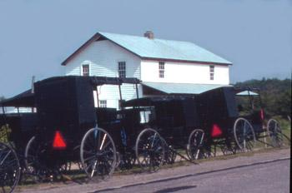
You keep an eye open for horses; for two miles you see nothing, then all of a sudden, look! Coming towards you on the other side of the road, two black horse-drawn buggies! As they go by, your surprise turns to disbelief; what's going on? Are they making a movie about eighteenth century America? The men and the women in the buggy look like they jumped out of a novel by Fennimore Cooper.
Then, another mile and things get even stranger; beside a neat-looking farm-house, there is a whole line of buggies. In the door of the house, half a dozen men in black coats, and with long beards, are talking while some women dressed in a curiously ancient fashion are sitting on a bench. Is this 2020 or 1720? You drive on, wondering what has happened to this part of the United States of America? Have you driven into a time-warp, and without realizing it, gone back 300 years, or is it the people you've just seen who're stuck in a time-warp? A quick inquiry at the nearest gas station gives you the answer; you are in Amish country, and the men and women you have just seen are Amish, part of a strange religious group that settled in America in the 18th century, and much of whose lifestyle has changed little since then. If you had seen the movie "Witness", you would have already known something about the Amish, how their community is strictly religious and self-contained, how Amish people do without the essentials of modern-day life such as electricity and cars, and how they do not mix with people outside of their own community. It is virtually unheard of for anyone to become an Amish, who was not born an Amish. This is about all that most Americans know about Amish people, unless, that is, they actually live near them and come across them in daily life. So who are they?
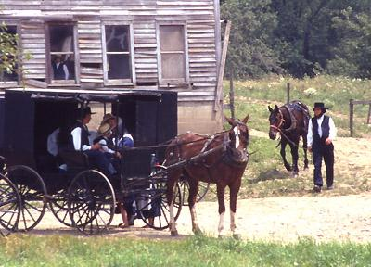
In brief, the Amish are members of an ultra-protestant religious movement that first came to America from the upper Rhine valley over three hundred years ago, and have kept their traditions and lifestyles. They are very law-abiding citizens, and their community is one in which there is little crime, or at least little reported crime. Amish families are patriarchal and live strict lives, following the same code of morals as their ancestors. In a sense, they are indeed stuck in a time-warp.
Yet the most remarkable things to note about the Amish are not their quaint lifestyles and their home-made clothes, but the expansion of their community, its efficiency, its social cohesion, and their recent adoption of "green" technology, including wind-power and solar energy. Although they work the land using traditional horse-drawn machines, and use no chemical fertilizers, their agriculture is - interestingly - among the most productive in North America!
While white America is, on the whole, a population that is stable in numbers, the Amish community is growing faster than virtually any other community in the USA. In the 40 years from 1950 to 1990, the number of Amish in Lancaster County, Pennsylvania, the original and still the largest Amish community in the USA, grew by exactly 400%, all by natural growth, not through the influx of immigrants. The Amish do not keep statistics, but it is fairly safe to assume that the total Amish population of the United States in the year 1900 was no more than a couple of thousand; today the Old Order Amish, those who have kept up the strictest traditions of their religion and society, number over 100,000, spread in communities across the eastern US and Ontario. The total number of Amish living in the United States in June 2020 was estimated at over 344,000... an increase of almost 90% since the start of the twenty-first century.

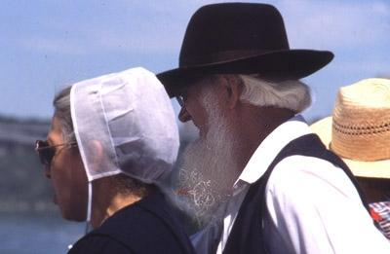
Amish, who reject modern medicine and all forms of birth control, have some of the biggest families in America, with an average of over six children per family. Few abandon their community. Amish teenagers tend to be as normally rebellious as any other American teens, until they are baptized. Until this happens, they are not obliged to conform to the strict Amish codes of dress, hairstyle and behavior, and many make the most of this liberty; before baptism, Amish teenagers behave much like other American teens; up to 30% of older unbaptized Amish teens own cars, and 40% have drivers licenses! Amish teens also enjoy baseball, dancing and even alcohol! Amish baptism takes place between the ages of 16 and 21, sometimes even later.

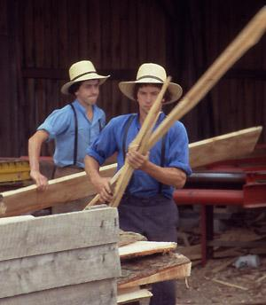
Amish youth working at the family sawmill

The fact that only about 18% of young Amish abandon the austere way of life of their ancestors is not the only reason why the community is growing so fast. Other factors include increasing life-expectancy, and higher standards of living. As for machines and modernity, Amish families do not live a primitive life; while they reject the use of mains electricity in the home, they accept the use of kerosene and efficient wood-burning stoves that provide plenty of light and heat and comfort in their homes; and they are certainly not out of touch with technology. It was estimated that in 2007, 80% of homes in some Amish communities were using wind or solar power! In this respect, far from being stuck in the past, they can be considered as one of the most advanced communities in the world!
As for leisure, it is not one of their major preoccupations! While they do not have televisions or radios, they have other social activities; yet Amish leaders actually fear that the development of a cult of leisure could rapidly destroy their society.
Contrary to popular belief, the Amish are not cut off from the rest of America; like any farmers, they need markets for their products and suppliers for their goods; some work for non-Amish employers. Many have non-Amish neighbors. They know what is going on in the rest of the United States, and like many other Americans, they are alarmed by many modern developments. This too explains why most young Amish opt to carry on with the hard-working and strict way of life of their community. Though Amish life is hard in many ways, it is free of most of the pressures and problems of the rest of American society. As long as this lifestyle is not forced into radical change, many of those who have been brought up in it will continue to see it as an attractive option.
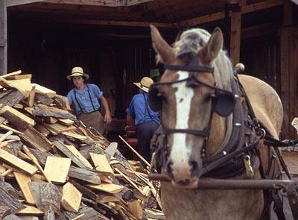  Horses are the motive power  in Amish farms | 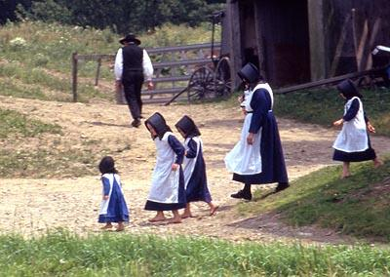  Amish family; note how the children  are not wearing shoes

Active Vocabulary
To live a lifestyle, a road sign, a highway, a buggy, a neat-looking house, to be self-contained, to mix with people, law-abiding citizens, solar energy, to reject smth.

Translate into English:

Ніхто не має сумнівів у тому, що американське суспільство обирає сучасний ритм життя. Але це не стосується окремої групи людей, які звуть себе Амішами. Ці люди належать до релігійної спільноти. Цікавим є той факт, що ці люди не змінюють стиль свого життя вже більше двох століть. Неможливо навіть уявити собі, але ці люди не використовують ніякі сучасні прилади, не користуються електроенергією та навіть не дивляться телевізор. І це є для них нормою. Вони навіть одяг шиють собі самі. Чи можливо уявити сьогодні життя сучасної людини без комп’ютера або телевізора або пральної машини? А ці люди обходяться без всіх цих приладів та вони абсолютно впевнені, що їх стиль життя, цей вибір який вони зробили є цілком правильним та розумним.

Issues for discussion:

- What factors influence the lifestyle we choose?
- Can a modern person live without a computer?
- What do you think: Amish people are satisfied with their lifestyle?

TEXT 2
Aeroponics; feeding tomorrow's world?

If our world is to survive for much longer, we have no choice but to reduce the use of natural resources and cut out wastage. Compared to traditional agriculture, aeroponics does both.

The world's population is expected to continue growing until the end of the twenty-first century; that at least was the general consensus of experts until 2019. Maybe in the new post-Covid reality, the rate of growth will slow; but even so, unless Covid-19 or some other new virus causes millions more deaths than initially predicted, the world's population will continue to grow, putting ever-increasing pressure on the natural environment, on resources, on living space, and most critically on food and water. Aeroponics will be part of the solution.
According to a United Nations FAO report published in 2011, almost half of the fruit and vegetables produced in the world go to waste – they never get consumed by the humans for whom they are grown.
Wastage occurs throughout the production and distribution cycle, during production, during transformation, during transport, and even –notably in developed economies – after purchase by the final customer.
Fifty percent of all fruit and vegetables going to waste, that is an enormous amount of wastage, and not just in economic terms. This wastage has a huge impact in terms of natural resources, particularly space and water, which in turn have huge implications for the global environment.
Cutting out all waste in the production and distribution of food is an impossible goal. Even people living in small eco-sustainable communities generate waste. Even in organic crop production, pests and disease cause wastage; and even if harvested and distributed locally, part of a crop will always be wasted.
But there is a large difference between wasting fifty percent of all fruit and vegetables produced worldwide, and the unreachable goal of achieving no waste at all. Between 50% and zero, there is plenty of scope for significantly reducing the volume of food waste worldwide simply through the use of new more efficient production methods.
Studies have shown that packaging and distribution systems account for about 25% of total wastage of fresh fruit and vegetables, leaving plenty of opportunity for improvement. In an ideal world, and as in the past, much of the food consumed in cities would be produced locally, not shipped thousands of miles as happens today.
In 1998, the US Department of Agriculture released a study into fruit and vegetables arriving at the Chicago Terminal Market, the main point of distribution for the American Middle West. The report showed that basic vegetables including lettuce, broccoli, peas or cauliflowers all traveled over 2000 miles (over 3000 km) before reaching the market... and before being shipped on to supermarkets across the region. Yet Chicago is in the heart of a massive agricultural area. Granted it can get pretty cold in winter, but with modern agricultural techniques, the Midwest could be self-sufficient for many types of fruit and vegetables, cutting out the massive environmental cost of shipping tons of vegetables half way across a continent.
Since 2011, Chicago's O'Hare airport has been home to an aeroponic garden (photo top of page), where people can see how vegetables can be grown in an environment that is not only without soil but even without any permanent medium in which to grow. In this experimental garden, plants are grown, as the name suggests.. in the air, their roots hanging down in nothing.
Hydroponics, growing plants in troughs of nutrient-rich water, has been developing since the 1970's. Aeroponics takes things one step further, by removing the water and replacing it with air. Not just air, obviously; while plants are grown with roots hanging in the air, these roots are regularly sprayed with a nutrient-rich solution that gives them just what they need for optimum growth. It's very high-tech, it's not cheap, and it's a long way from currently popular organic farming techniques. Yet in many ways, aeroponics is actually more environment-friendly than even the most strictly managed traditional organic farming methods. And it's down to one factor: waste.
Traditional farming is wasteful; modern intensive agriculture relies on large inputs of external resources, notably heat, water and nutrients. The vast amounts of water used by agriculture are already causing serious problems in many parts of the world; beneath California's San Joaquim Valley, the world's most productive agricultural area, water tables have been dropping for almost a century, and scientists estimate that the land... not the water table below it... has sunk by over 8 metres in some parts. NASA calculate that Southern California had a "water deficit" of 4.2 gigatons per year from 2002 to 2015.
Aeroponic agriculture reduces water waste to zero. The only water used is what is actually taken up by the roots of plants when they are sprayed. Any water not used can be collected and reused.
The same goes for nutrients; in traditional agriculture, plants only extract a small proportion of nutrients from the ground, and good ground will have many nutrients in it that will not be used at all by the crops grown on it. In an age of diminishing natural resources, traditional agriculture uses millions of tons of chemical fertilizer each year, much of which goes to waste. In Brittany, France, many streams and beaches have been seriously polluted by nutrient-rich water running off fields, causing "algal bloom" along the seashore and covering some beaches in green slime. With aeroponic agriculture, no nutrients are lost, so there is no risk of unintended pollution.
One big advantage of traditional agriculture is that it almost always uses natural heat and light, even if under glass or plastic. Aeroponic agriculture, by contrast, may require artificial heat and light, specially if practised indoors. But with the development of small-scale locally-sited renewable energy production, and highly energy-efficient buildings and lighting systems, large-scale indoor aeroponic vegetable growing units are liable to be a feature of tomorrow's cities.
If all the lettuces consumed in Chicago in winter could be grown locally, in carbon-neutral zero-waste aeroponic "farms", instead of being brought in by truck from

Active Vocabulary:
Aeroponics, to predict, wastage, to have a huge impact, organic crop production, food waste.

Translate into English:
В сучасному світі екологічні проблеми стають найактуальнішими. Люди так довго нехтували проблемами зовнішнього середовища, що зараз екологічні проблеми вийшли на перший план.
Актуальні проблеми сучасної регіональної екології пов’язані, зокрема, з переходом великих заводів від використання природного газу на дешевше, але екологічно шкідливе тверде паливо. Такий перехід впливає на якість повітря та довкілля в цілому. При цьому підприємства, що забруднюють атмосферу, сплачують екологічний податок, який має компенсувати завдану шкоду, хоча ефективність використання цих коштів залишається сумнівною.
Окрему загрозу становить діяльність вугільної промисловості Через її застарілі технології утворюються терикони, які викликають провали ґрунту та погіршують якість підземних вод.

Issues for discussion
a) Environment. Is it a global problem?
b) Do people care about environment in their everyday life? Why?

TEXT 3

Queen Elizabeth II died on September 8th 2022. "The Queen", as she was generally known, was born in 1926, and came to the throne in 1952 as a young mother in her mid-twenties. History sometimes takes an unexpected route, the future cannot be foreseen, and indeed if British history had gone according to plan in the 1930s, Elizabeth would never have become Queen at all. Photo right: The Queen was still performing official business at the age of 94.

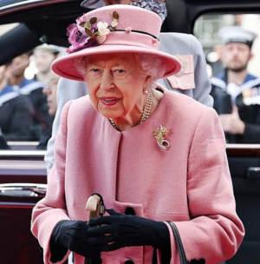

Queen Elizabeth II, who in 2015 became the longest-serving British monarch in history, was not born to be queen. In fact, as a child in pre-war Britain, she never expected to be queen. She – and everyone else – imagined that her uncle Edward, the King's eldest son, would follow normal tradition and become the next British monarch when his father, King George V, died; and that after him, the crown would pass to his son or daughter, assuming that he married and produced an heir.

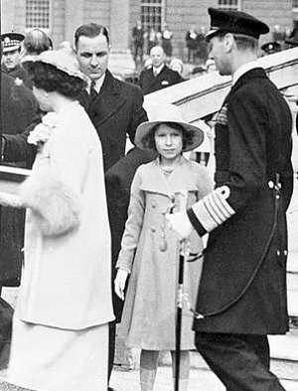
1937 - Aged 11. Princess Elizabeth with her parents, already on official business trip. Her father has just become king George VI, and Elizabeth is now next in line to the throne.

Elizabeth was the daughter of King George V’s second son, Albert George. Albert, known in the family as Bertie, was a demure young man, much less popular and active than his older brother; he was shy and not very good at talking in public. Bertie’s shyness and his speech impediment were both magnificently portrayed in the 2010 movie The King’s speech. Bertie, it was presumed, would remain the younger brother of the next king, Edward VIII, and his two daughters, Elizabeth and Margaret, would spend their life as “minor royals", nieces of the king, or, when Edward VIII died, aunts of the next monarch, whether this was a king or a queen.
Yet as often happens, history did not go forward according to plan. In January 1936, King George V died at the age of 70, and the crown automatically passed to his elder son Edward, Prince of Wales, who immediately became King Edward VIII. The British government was alarmed; was seen as a playboy, notorious for his affairs with married women. The government, of course, could not remove a king, but they made it plain to him that he had to change his ways. Edward did not change his ways; on the contrary, he announced on November 16th that he was going to marry his lover, Mrs. Wallace Simpson, a twice-divorced American. The British establishment was rocked to the core by this news: social traditions in those days were strict, and it was expected that the future King of England would marry a young lady from the British or European aristocracy, not a divorced commoner from the USA.

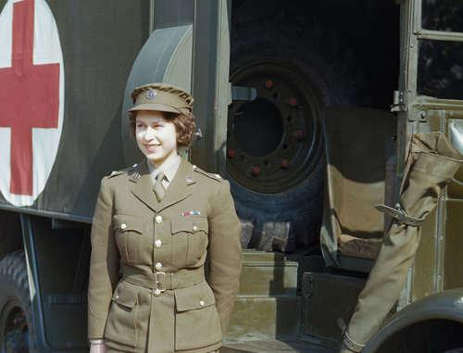
Aged 19, Princess Elizabeth signed up as an army driver during the final year of the Second World War.. She did not imagine that 7 years later, she would be Queen

Eventually Edward VIII realized that his plan to marry Wallace Simpson was going to cause a constitutional crisis and on 11th December, before he had even been crowned, he abdicated, choosing love over kingship. It is probably fair to say that abdicating the kingship and marrying Wallace was for him not a very difficult choice, as during his few short months of reign, he had amply shown that he was ill-suited to carry out the very heavy duties that fall to a head of state.
So it was that Edward's younger brother Bertie - Albert George - found himself thrust into the limelight as he became the next king of England, a role which neither he nor his family had ever expected. He chose the regnal name George VI.
George VI had two daughters but no sons, so when he ascended to the throne as King of England on 12th May 1937, at the age of 41, it was his elder daughter, Elizabeth, aged 11, who suddenly found herself next in line to the British throne.
Though Britain was plunged into war between 1939 and 1945, Elizabeth and the British people in general assumed that King George VI would live to a reasonable age, remaining king through until at least the 1960s or 1970s. As a princess, and first in line to the throne, Elizabeth nonetheless began to take up some royal duties after the war ended, but with no sense of urgency. Her father George VI was very different from his elder brother Edward, and took the duties of kingship very seriously. In the post-war years, he was a very popular monarch, respected for his hard work and his attachment to his people. So it came as a bombshell when, on 6th February 1952, George VI, who was a heavy smoker, died of lung cancer at the age of just 56. While it was well-known that the King was not in good health, no-one was prepared for him to die so young, least of all his daughter Princess Elizabeth, who got the news of her father’s death while on an official tour in Africa. She and her husband Prince Philip, the Duke of Edinburgh, immediately returned to Britain, where, at the age of just 26, she took up the heavy duties of Queen of England, the United Kingdom and other realms.

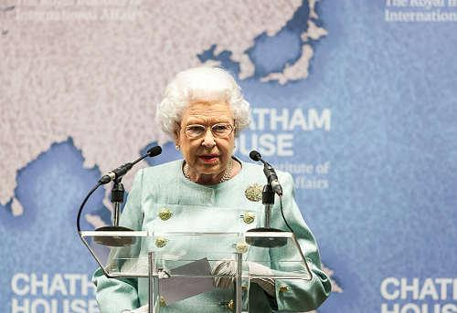
2014 - Aged 88, Queen Elizabeth II was still carrying out most of her official business as head of state – including official visits and speeches

As a young child, Elizabeth never expected to become Queen; but she did so, and has now achieved the distinction of being the longest-serving British monarch of all time, beating the record set by her great-great-grandmother Queen Victoria, who reigned for 64 years – most of the nineteenth century.
At the age of 94, Queen Elizabeth II still carries out many of the essential jobs of the Head of State, though age and the Covid epidemic have combined to significantly reduce her workload since 2020. She still has regular discussions with her Prime Minister, and signs the documents that require Royal Assent. While most people of her age have been retired for close on 30 years, Queen Elizabeth II often intimated that she would never retire, and would carry out her duties to the country and to her other dominions as long as she was able to.
That is exactly what she did. On 8th September 2022, Queen Elizabeth II died peacefully at her summer residence, the castle of Balmoral in Scotland. She is succeed by her eldest son Charles, who has become King Charles III.

Active Vocabulary
To come to the throne, to foresee the future, to be good at doing smth, impediment, to be alarmed, kingship, to carry out the duties, essential jobs

Translate into English:
У Великій Британії немає чіткого юридичного чи формального визначення члена королівської сім'ї, як правило членами королівської сім'ї вважаються монарх, чоловік монарха, овдовілий чоловік монарха, діти монарха, онуки монарха по чоловічій лінії, подружжя і овдовілі дружини синів і онуків по чоловічій лінії монарха. Члени британської королівської сім'ї носять титули Їх Королівської Величності і Їх Королівської Високості.
Історично члени британської королівської сім'ї представляли монарха по всій Британській імперії займали відповідальні та представницькі пости, на сьогоднішній день вони виконують церемоніальні та соціальні функції як у Великій Британії, так і за кордоном, і крім монарха не мають ніякої конституційної ролі в справах уряду.

Issues for discussion:
a) It is often said, that Britain is the country of traditions. What does it mean in your opinion?
b) Why is the royal family so popular in Great Britain. What do you think?
c) Who are the best loved members of the royal family? What do you know about it?

TEXT 4

So just who are the English?
Just who - or what - are the English? That is a very good question, and one which nowadays the English themselves find it hard to answer. While the Scots, the Welsh and the Irish each seem able to define themselves by some form of national identity, the English cannot. So who are they? And why is there no real "English" identity within the United Kingdom?

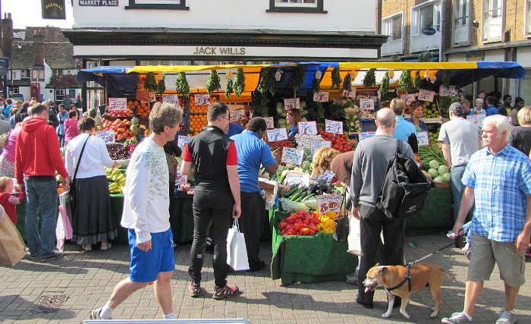
What do we mean by the word "English"? There is, of course, the language - the one that has become the world's main means of verbal communication. But what about "the English" - in the sense of people from England?
Ask a Cockney from London, or a Brummie from Birmingham, or a Geordie from Newcastle about their nationality, and he or she will most probably answer "English". Yet look at his or her passport, and you'll see that it is a "British" passport, defining the holder as a citizen of the United Kingdom. Nowhere is there any mention of the word "England".
English grammar has now got clearer and more understandable

Now of course the same contradiction exists for the Scots, the Northern Irish and the Welsh; they too are all "British", and "citizens of the United Kingdom"; but they too will quite probably tell you that they are from Scotland, Northern Ireland, or Wales; and in saying that, they are relating themselves to a very clearly defined national identity.
Everyone knows what Scotland is, and who the Scots are. Within the United Kingdom, Scotland is well defined, and there can be no ambiguity about the meaning of the adjectives Scottish and Scots; Scotland has its national symbols, its tartans, its accents, its regional newspapers, and - since 1999 - its national parliament. Indeed, in 2024 the leader of the Scottish Nationalist Party, and First Minister of Scotland, is a man by the name of Humza Yousaf, a Scot whose grandparents were Pakistani.
The Welsh too know who they are; Wales has its strong cultural traditions, its language which is taught in all Welsh schools, and its regional assembly. As for the people of Northern Ireland, even in this divided community people know who and what they are; indeed the feeling of national identity runs more strongly here than in any other part of the UK - with the problem that the province contains two groups of people, with two conflicting ideas about their national identity... which has caused a lot of trouble.
But what of the English? Though people from England readily talk of themselves as being "English", ask them what "English" means, and they will often hesitate.
"Well, British," is a common response; and indeed for years the English have tended to treat the two terms as synonyms - which of course they are not. The confusion is understandable; of the United Kingdom's 63 million inhabitants, over 53 million - or 84% - live in England, meaning that England is and always has been the dominant power or partner among the nations of the United Kingdom. Scotland, the second largest nation, has just 5.3 million inhabitants, or 8.6% of the total population.
With a permanent and absolute majority of people and power within the United Kingdom, the English, until recently, were not really bothered by questions of national identity. England was Britain, and London the capital of both. During the time of the Empire, leaders from all parts of Britain were far too busy with international affairs, to worry too much about national identities. In the 19th century, only the Irish (in those days part of the UK) were struggling to establish their own national identity - which they attained in 1921.
Today things are very different. There is no more Empire, and Britain is just a nation like many others. Since the 1970's Scots and Welsh nationalists have helped revive the national identities of their parts of Britain. Today, every nation in the United Kingdom has its own national parliament or assembly... with one exception: England.
Perhaps it is therefore not surprising that the English have started to question their own identity. Just what is England? and who are the English? Two good questions.

Identity and diversity

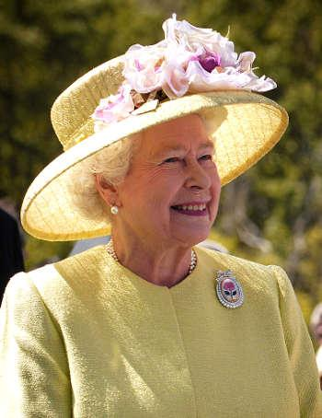
Queen Elizabeth was often called the "Queen of England"

The fact that a country is diverse does not mean that it cannot have a clear national identity. Countries like France or the USA are very diverse; but England, unlike these others, is neither a "state" (with a head of state and a constitution), nor does it have a "national" culture to distinguish it. The English language is not a sign of national identity, as it is the native language of 360 million people worldwide; and the "Queen of England" is not the English head of state, she is the head of state of Britain and several other countries too. Under such circumstances, England's lack of national identity is understandable, if not inevitable. In his bestselling book, The English, Jeremy Paxman suggested that Englishness is really a state of mind. This is perhaps going too far; England exists, and in spite of its diversity it has a geographic identity.
Does it need more? Maybe not. Writing in the Independent newspaper, David Aaronovitch (an Englishman whose father was of London Jewish origin and whose mother came from the rural south west) concluded: "Maybe the English are one of the first post-national nations, with much of our identity defined by our ability not to exclude, but to include, and not by the history of our country, but by the possibilities it offers."
Maybe. But not everyone would agree with that.

Active Vocabulary;
National Identity, verbal communication, ambiguity, dominant power, diversity

Translate into English:
Утримання королівської сім'ї насправді обходиться британським платникам податків у 510 млн фунтів (680 млн доларів) на рік, а не в 86 мільйонів, які офіційно виділяють з бюджету - так вважає британська антимонархічна організація.
У своїй новій доповіді громадська організація Republic ("Республіка") підсумувала не тільки витрати на утримання короля і принців з принцесами, але й втрати, яких, на її думку, зазнає скарбниця Британії через те, що багато землі і нерухомості належить не державі, а королю.
Безпосередньо з бюджету у вигляді так званого "гранта суверена" зараз виділяють 86 млн фунтів на рік (близько 115 млн доларів).
За законом, з 2011 року ця сума розраховується щорічно з урахуванням доходів Володінь корони (Crown Estate), які монарх в обмін на щорічний грант віддає державі. Тобто, за формою і суттю це повернення королівському дому певного відсотка доходів з Володінь корони.
Володіння корони включають численні об'єкти нерухомості в Лондоні та інших містах, а також великі земельні ділянки. Загальна вартість цієї власності - близько 16 млрд фунтів. Усе це здається в оренду і в 2023 році принесло 443 млн фунтів доходу.

Issues for discussion:
a) Who is known as English people?
b) What phrases do English people use?
c) What have you heard about English people?

TEXT 5
The English - a short history

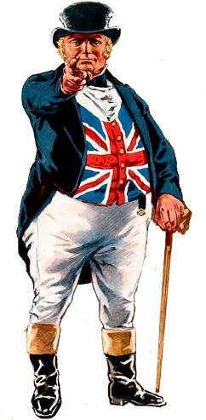

The character of John Bull is a confusing stereotype. He is the cartoon Englishman, but he wears a British flag.
For almost 300 years, a fictitious character by the name of John Bull has been used as a representation of the " true Englishman", as if the "English" were a homogenous race of people.
They are not. In reality, the English are among the more diverse races in Europe. The "Angles", who gave their name to the country, were people from northern Germany, who came over with the Saxons and the Jutes during the "Dark Ages", over 1200 years ago, conquered the "British", who were Celts, and established their settlements. They were soon followed by Vikings, from Scandinavia, who occupied a large part of eastern Britain. The last successful invasion of England came in 1066, when William the Conqueror, duke of Normandy, defeated the English armies, had himself crowned king of England, and established a new Anglo-Norman state in which everyone important spoke French. Since that time, England has never again been invaded or colonized by people from across the sea; yet in ethnic terms, England has continued to evolve. During the Middle Ages, large numbers of men and women came to England from Flanders, to work in the cloth trade; there were also Jews from Europe, who kept coming to England over the centuries. In the 17th Century, thousands of French Huguenot Protestants fled from religious persecution and came to England, adding 1% to the total British population, and considerably more in the south of England where most of them settled.
In the twentieth century, many more people emigrated to England: victims of Nazi and Stalinist persecution, men and women from the Commonwealth, and workers from Europe. Most of those who arrived before 1960 took British nationality, and some of their children think of themselves as being English. Most consider themselves as British.
Thus it is clear that the English, Shakespeare's "happy breed", are a very mixed race. There are few people in today's England, if any at all, who can claim to be pure ethnic "Englishmen" (whatever that may mean.). It can be argued that there is indeed no such thing as an English ethnicity.
In political terms, the people who talk most about "England" and "Englishness" tend to be Conservatives or on the political right; yet many Conservative politicians today and in the past have come from non-British backgrounds. The most famous Conservative prime minister of the 19th century was Benjamin Disraeli; and two of the four senior ministers in the Conservative government in 2020, Rishi Sunak (Chancellor of the Exchequer) and Priti Patel (Home Secretary), were of Indian origin. More surprisingly, one of the strongest voices on the "English nationalist" wing of the Conservative Party is a staunch Brexiteer with the name of Mark Francois, whose mother was Italian. Try understanding that.
The question of England's identity is really a big issue, and one that is certain to be even more in the news if or when the Scots should demand independence.... as the Scottish Nationalist Party hopes to do again soon. The nature of English identity has become particularly questioned since the Brexit referendum, where a majority of people in England voted for Brexit, while a majority of people in Scotland and Northern Ireland voted against it.
Aaronovitch's idea of the "post national nation" makes a lot of sense in the light of the fact that England's "identity crisis" is not a result of nationalism, but the result of the uncoupling of the long-accepted equation England=Britain.
Away from the football field and Brexit, English nationalism is virtually non-existent. Major political parties being UK-based, not England-based, none of them espouse English nationalism as a cause; those English nationalists who sometimes surface in the Conservative party are even today sidelined by the party, which is very keen to maintain its British identity - even if it is largely a de facto English party these days. The expression "Little Englander", often used to describe people with English nationalist sentiments, is pejorative. Brainstorming: What do the words "England" and "Scotland" mean to your students? What things, people, ideas, ideals, or words do they associate with each of these two countries? Divide the board into two halves, and write up the words associated with each country in its half, as your students suggest them.
You will probably end up with more words under Scotland than under England - or at least, you will do so if you remove all the words that are really associated with "Britain", not "England". If this is the case, you have begun to show your students how "England" is short on identity.

Active Vocabulary:
A confusing stereotype, a fictitious character, homogenous race of people, ethnic terms, pejorative, brainstorming.

Translate into English:
Ідея Аароновича про "постнаціональну націю" має багато сенсу в світлі того факту, що "криза ідентичності" Англії не є наслідком націоналізму, а результатом розриву давно прийнятого рівняння Англія=Британія. З політичної точки зору, люди, які найбільше говорять про "Англію" та "англійськість", як правило, є консерваторами або політично правими; проте багато політиків-консерваторів сьогодні і в минулому походять з небританського походження. Питання ідентичності Англії - це справді велике питання, яке, безсумнівно, ще більше з'явиться в новинах, якщо або коли шотландці вимагатимуть незалежності, як це сподівається зробити Шотландська націоналістична партія незабаром знову. Персонаж Джона Булла - це заплутаний стереотип. Це мультяшний англієць, але він носить британський прапор. Протягом майже 300 років вигаданий персонаж на ім'я Джон Булл використовувався як уособлення "справжнього англійця", так, ніби "англійці" були однорідною расою людей.

Issues for discussion:
a) What is considered an English person?
b) How are English people described?
c) Where are English people from?

TEXT 6

When, in 1964, members of a Trinidadian steel band were invited to take part in a street festival in Notting Hill, in the west of London, none of them realized that they were going to give birth to Europe’s greatest street carnival.



There had been racial tension in Britain in the late 1950’s, and the Black people who had come over from the West Indies to work in London found it hard to mix with Londoners. As a way of breaking the ice, the idea of a street festival was suggested; street festivals being popular events on the Caribbean islands, the original organizers suggested that the sight and sound of a Trinidadian steel band playing on the streets of Notting Hill would encourage local residents, both black and white, to come out on the street and enjoy themselves for an afternoon.
The first festival was an immediate success; once the black people of Notting Hill heard the music of the steel band, they came out into the street to dance and enjoy themselves as they might have done back home in the West Indies; attracted by the unusual and rhythmic sound of the steel band, others too came along to share in the experience. In short, the first festival was such a big success that the organizers decided to organize another one the following year.
Since then, the Notting Hill Carnival has evolved into a huge multi-cultural arts festival, attended by up to two million people; besides being the annual high point of London’s Afro-Caribbean community, it now attracts hundreds of thousands of people from all over Britain and other countries, and has become the world’s second biggest carnival, second only to Rio.
Over the years, the carnival has grown in variety, reflecting the multi-colored and cosmopolitan nature of modern London; recent carnivals have seen the participation of groups from Afghanistan, Kurdistan, Bangladesh, Bulgaria, and many other countries, as well as musicians and dancers from other parts of Britain. In addition to the procession of exotic costumes and steel bands, there are now almost fifty static stages with bands playing different types of West Indian music, but also jazz, soul, and other popular varieties.
With so many people in attendance during the two days of the festival - the last Sunday and Monday in August - moments of tension and the occasional scuffles with the police are inevitable; yet in spite of the crowds, serious problems are rare. The vast majority of those who come to this festival come to have a good time, to finish off the Summer holiday period with a day or two of exoticism and color; they do not come looking for trouble.

FROM TRINIDAD TO LONDON

In Trinidad during the days of slavery, black slaves were forbidden to play musical instruments and wear costumes except on the occasion of the traditional imported European carnival, that took place six weeks before Easter. Slaves were also forbidden to be on the streets after dark, unless they were accompanying their master.
When slavery was abolished in British colonies in 1833, slaves took to the streets in song and dance; to celebrate their new-found freedom, they dressed up in fancy and colorful clothes and powdered their faces white, to mimic their former masters and show that they could be masters too.
In the years that followed, as slavery eventually disappeared from other parts of the new World, carnivals developed into great moments of celebration for the former slaves throughout a large part of the region; from Rio to New Orleans, by way of the Caribbean, people vied with each other to produce the most exotic and exciting carnival costumes. Even in 19th century Trinidad, it was amazing what some people managed to produce using the very limited resources available to them.
Today the situation is quite different; and although many Carnival costumes are now made up from left-overs and snippets, others are carefully made from material bought specially for the purpose. Yet regardless of how the costumes are made, the result is spectacular; a flamboyant display of color and originality that has earned itself a highly deserved place as the most important annual street festival in Britain.

Active Vocabulary:
Street carnival, racial tension, to mix with people, local residents, to be evolved into smth, a static stage.

Translate into English:
Перший фестиваль одразу ж мав успіх; як тільки чорношкіре населення Ноттінг-Гілла почуло музику сталевого гурту, вони вийшли на вулицю, щоб танцювати і веселитися, як вони могли б робити це вдома у Вест-Індії; приваблені незвичайним і ритмічним звучанням сталевого гурту, інші теж прийшли, щоб поділитися досвідом. Коротше кажучи, перший фестиваль мав такий великий успіх, що організатори вирішили організувати ще один наступного року. З роками карнавал став більш різноманітним, відображаючи багатобарвний і космополітичний характер сучасного Лондона; в останніх карнавалах брали участь колективи з Афганістану, Курдистану, Бангладеш, Болгарії та багатьох інших країн, а також музиканти і танцюристи з інших частин Британії. На додаток до ходи екзотичних костюмів і сталевих оркестрів, зараз існує майже півсотні статичних сцен, на яких виступають гурти, що грають різні види вест-індійської музики, а також джаз, соул та інші популярні різновиди. Сьогодні ситуація зовсім інша; і хоча багато карнавальних костюмів тепер зроблені з залишків і клаптиків, інші ретельно виготовлені з матеріалів, куплених спеціально для цієї мети.

Issues for discussion:
a) What is the point of Notting Hill Carnaval?
b) Is Notting Hill Carnival free?
c) What happens at carnival?

TEXT 7
American history
Though New York and Los Angeles are the current day capitals of the American music industry, it is half way between the two of them, in the Mississippi Valley, that the roots of American popular music are to be found.

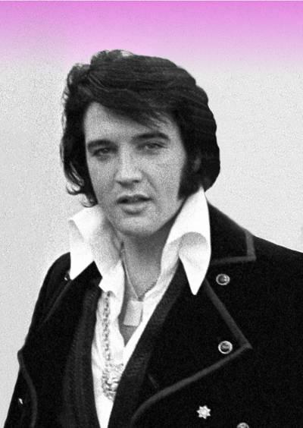
Elvis Presley - surely the most famous musician to have his roots in the Mississippi valley

There are six classic forms of American popular music; jazz, the blues, bluegrass, soul, rock 'n' roll, and country and western.
With the exception of bluegrass and country and western, the Mississippi valley is the birthplace of them all.
Like American culture in general, American music has evolved out of the different traditions that reached the New World from the old. But out of all the different types of music that reached the New World - from England, Ireland, Spain, France, Germany, Africa and many other places - one was to have a particularly significant impact: African music.
While European influences provided melody and a lyric tradition, African influences added a new sense of rhythm and new harmonies, which were to give rise to several new forms of music that were different from anything European.
New American forms of music developed among the slave communities working in the cotton fields near the mouth of the Mississippi; Christianized slaves developed gospel music and Spirituals, which soon became popular far beyond the rural states of the South.
Following emancipation, Blacks had much more opportunity to develop their musical talents, and many did exactly that, adding instrumentation to the essentially vocal tradition of the spiritual.
From the Spanish musical tradition they added the guitar, a popular instrument in the southern states which had been originally colonized by the Spanish. From a more general European tradition they added brass instruments such as trumpets, which were popular with the marching bands used at all kinds of ceremonial events in the American states.
It was thus in the late nineteenth century that two new forms of American music began to develop, both of them in the Mississippi valley.
Firstly there was the blues. In the cotton-growing Delta region of the state of Mississippi (not to be confused with the Mississippi Delta), the blues appeared in the 1870's, sometimes as a purely vocal tradition, at other times using the guitar as accompaniment. It was a form of music through which poor exploited Blacks expressed their sadness and their problems, their "blues". The sadness of the blues is evident both in the music itself, and in the titles of countless popular blues songs, such as Poor Boy Blues, Homesick Blues and many others.

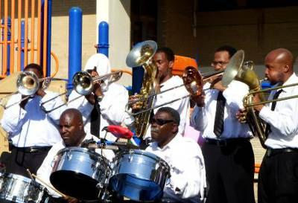
Traditional jazz band

Jazz, on the other hand, developed in and around New Orleans, as a type of music for festive moments and dancing. The most famous jazzman of all, Louis Armstrong (Satchmo) was born in New Orleans.
Both of these forms of music migrated up the Mississippi valley with the Blacks who went north in search of work in the early twentieth century. Satchmo was one of them; he went north, ending up in Chicago, where his "New Orleans Jazzmen" soon established a national reputation, thanks to the development of both radio and the gramophone.
In the 1920's, many of the Blacks who migrated north went looking for jobs in the booming American automobile industry, in and around Detroit, and it was here in "Motown", i.e. mo (tor) town, that soul music and other new varieties evolved.
With the advent of radio and records, all varieties of black music became increasingly popular. In the north Detroit became the capital of soul music; in the south New Orleans remained the capital of jazz; and between the two, at the heart of the Mississippi valley, Memphis became the center for an exciting new type of music; rhythm 'n' blues.

A compact English grammar with particular reference to modern American usage

This music soon attracted the attention not just of Blacks but of Whites too; and with very little change, R & B evolved into yet another new type of music; rock 'n' roll. Elvis Presley is the man who did most to help rock 'n' roll conquer first America, then the world, was in fact not a black musician, but a white boy from rural Mississippi, by the name of Elvis Aaron Presley. Elvis's family was poor, very poor; as a kid, Elvis lived in a two-room shack in Tupelo, Mississippi. There was not much to distinguish the lifestyle of his poor white family from that of the equally poor black families in the region, and young Elvis had plenty of contact with black culture and music.
After making his first records in Memphis, Elvis became the biggest rock star the world had ever seen; "the King". Yet he never abandoned his Mississippi valley roots, and it was in Memphis that he established his famous home, Graceland.
In the space of the last sixty years, rock 'n' roll has become the basis of popular music worldwide. In this respect, it could be argued that the Mississippi valley is the source of the greatest cultural phenomenon of the twentieth century.

Active Vocabulary:
A current day capital, gospel music, spirituals, brass instruments, a trumpet, ceremonial events, black culture.

Translate into English:
Існує шість класичних форм американської популярної музики: джаз, блюз, блюграсс, соул, рок-н-рол, кантрі та вестерн. За винятком блюграсу, кантрі та вестерну, долина Міссісіпі є батьківщиною всіх цих напрямків. У той час як європейські впливи забезпечили мелодію і ліричну традицію, африканські впливи додали нове відчуття ритму і нові гармонії, які повинні були дати початок кільком новим формам музики, що відрізнялися від усього європейського. Спочатку був блюз. У бавовняному регіоні Дельта штату Міссісіпі (не плутати з дельтою Міссісіпі) блюз з'явився в 1870-х роках, іноді як суто вокальна традиція, іноді з використанням гітари як акомпанементу. Це була форма музики, за допомогою якої бідні експлуатовані чорношкірі висловлювали свій смуток і свої проблеми, свій "блюз". Сум блюзу простежується як у самій музиці, так і в назвах незліченних популярних блюзових пісень, таких як Poor Boy Blues, Homesick Blues та багатьох інших.

Issues for discussion:
a) What is unique about American music?
b) What represents American music?
c) What is the most common American music?

TEXT 8

A hundred years ago, you could not buy or consume alcoholic drinks in the United States. It was the age of "prohibition", and a time when criminals controlled a whole industry. The most famous gangster was Al Capone.

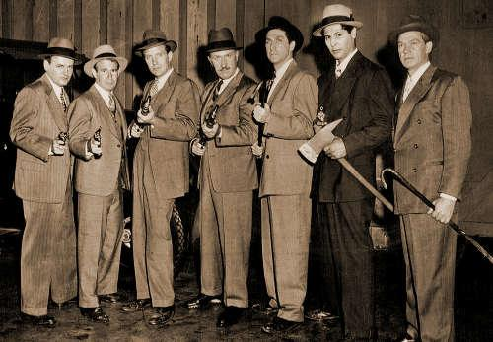
The "Untouchables" - from a 1950s TV series. They fought to bring the big criminal gangs to justice. They could not be "bought"

America is the land of Liberty. You can think what you want to think, and you can say what you want to say; but you cannot always do what you want to do — without breaking the law.
Today you cannot use hard drugs, because it is against the law. The law has decided that drugs are dangerous, and most people believe that the law is right. Today, in many places, you cannot smoke a cigarette in the street. But today, you can sit in a bar and drink a beer — just as long as you are not below the age limit; a hundred years ago, you could not. America was dry. Alcohol was illegal. You could neither drink it nor make it, nor buy it, nor import it, nor sell it.
lf you did, you could go to prison.
Alcohol became illegal in the year 1919; it remained illegal for fourteen years. However, it never disappeared! Before 1919 alcoholic drinks were very popular in the United States. There was a big drinks industry, which employed a great number of people. Suddenly, in 1919, the industry had to stop!
Of course, it could not stop. It stopped officially, but it continued to prosper - unofficially. In place of big business, there was big crime. The Mafia took control of the distribution, and the bosses of the Mafia replaced the bosses of the breweries and the distilleries.

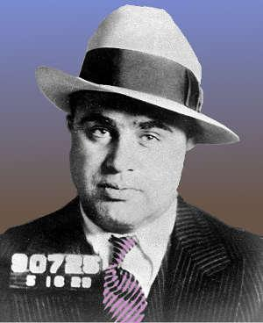
Al Capone, after he was arrested
The biggest gangster of them all was Al Capone, who came from New York and operated in Chicago. Capone controlled a vast empire of crime. He was so powerful that he could control anyone he wanted to. He could "buy" policemen, he could "buy" politicians. He was "untouchable". In his fortress at Chicago, he was quite safe, because he was a friend of the Mayor, "Big" Bill Thompson.
Big Bill liked Capone, because he liked his drink. Bill and his drinking friends in the authorities made sure that Capone did not have much trouble. Capone had lots of enemies, but most of his enemies were frightened of him. They knew that Al could kill them, and would kill them, if they were not careful.
Most policemen were very careful not to get in the way of Al Capone, unless they had to. Most policemen, but not all. A small group of policemen, known as "the Untouchables", were determined that Al Capone would not escape from justice forever. They took several years to do their work, but in the end they succeeded. Al Capone was finally sent to prison.
However, he was never accused of killing, nor of selling alcohol. He was too clever for that. No evidence could incriminate him for that. He was sent to prison for not paying taxes.
Active Vocabulary:
Untouchable, a criminal gang, justice, to be illegal, a big crime, empire of crime, to escape from justice.

Translate into English:
Сто років тому в Сполучених Штатах не можна було ні купувати, ні вживати алкогольні напої. Це була епоха «сухого закону» і час, коли злочинці контролювали цілу індустрію. Найвідомішим гангстером був Аль Капоне. Америка - це країна свободи. Ви можете думати те, що хочете думати, і говорити те, що хочете говорити; але ви не завжди можете робити те, що хочете робити, не порушуючи закон. Сьогодні ти не можеш вживати важкі наркотики, тому що це протизаконно. Закон вирішив, що наркотики небезпечні, і більшість людей вірить, що закон правий. Сьогодні в багатьох місцях не можна викурити сигарету на вулиці. Але сьогодні ви можете сидіти в барі і пити пиво - якщо ви не молодше певного віку; сто років тому ви не могли цього робити. Америка була сухою. Алкоголь був поза законом. Його не можна було ні пити, ні виробляти, ні купувати, ні імпортувати, ні продавати. Більшість поліцейських були дуже обережними і не ставали на шляху Аль Капоне, якщо тільки не було необхідності. Більшість, але не всі. Невелика група поліцейських, відомих як "Недоторканні", була рішуче налаштована на те, що Аль Капоне не вдасться втекти від правосуддя назавжди.

Issues for discussion:
a) What are interesting facts about Al Capone?
b) What was Al Capone famous for saying?
c) Was Al Capone a hero?

TEXT 9

Queen Elizabeth II died on September 8th 2022, after 70 years on the British throne. She has been succeeded by her eldest son Charles. The man who, until September 2022 was "Prince Charles" is now King Charles III

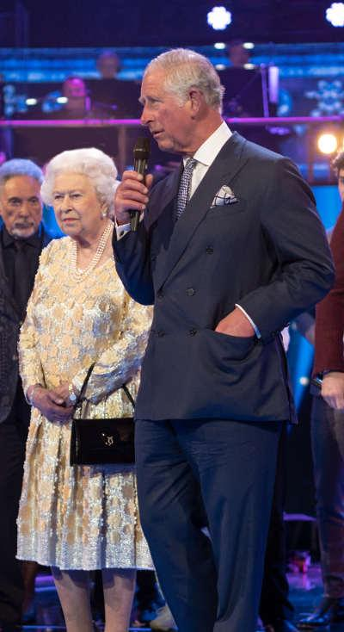
Prince Charles - now King Charles - often accompanied or replaced the Queen on official duties, some formal, others less formal
Very few people alive in Britain today remember the time when Britain last had a king. Elizabeth II was Queen of England for 70 years, from 1952 to 2022, so only the very oldest people remember the last king, her father George VI.
Queen Elizabeth has marked life and times in Britain for the past seven decades, and since her death, Britain has entered a new period of history. The Second Elizabethan age is over.
For millions of people in Britain, and in other countries too, the death of the Queen has been like losing a grandmother, since the Queen was part of national life, part of the national family, and a very popular figure. Opinion polls in 2020 showed that over 80% of people in Britain appreciated the Queen.
There has been a moment of national trauma following her death; the Queen was not just "a royal", she was the Queen, a person whose image people see every day, and will continue to see for some time, on coins, on banknotes, on stamps, in magazines, in public places.

King Charles III

While Charles is not unpopular, he is less appreciated than his mother the Queen, and less popular than his son Prince William.
Charles was born in 1948, and has spent his life in the shadow of the Queen. He has the image of a gentleman farmer, and is still actively involved in the agricultural life of his estates. Like his father, the Duke of Edinburgh, who was president of the WWF, Charles is very concerned about the environment and the natural world, and his farms are known for their organic produce. Indeed, Charles's farms became organic in 1985, long before the organic boom of recent years, and "Duchy Organic", set up by Charles, is one of the biggest brands of organic foods in the UK, sold in the Waitrose supermarkets.

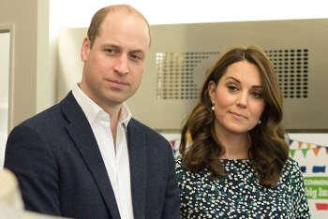
William has now become the new Prince of Wales - the historic title of the heir to the throne
Charles has also spent a lot of time trying to help underprivileged youth in Britain's inner cities. His "Prince's Trust" is a charity that has helped thousands of kids from poor parts of Britain's cities to get good training and good jobs. He has also been active on the world stage, and in 2020 he encouraged world leaders at the Davos summit "to reset capitalism", in order to prevent the worst effects of climate change. As a prince, he could say and do what he wanted; as Head of State, he will have to be more neutral. That may be difficult for him.
How long will Charles be king? Not as long as his mother, that is sure. He came to the throne at the age of 73, an age when most people are thinking more about retirement than taking up a big and important job. If he lives as long as his mother, he will remain king for over 20 years, longer than most heads of state. If he is a good king, then one day he will probably be succeeded by his elder son William. Few people want Britain to become a republic. A poll in 2012 showed that 80% of people in Britain wanted the monarchy to continue, with only 13% wanting a republic. Perhaps this is understandable; in Britain, as in many other countries, politicians are not particularly popular these days! God save the King!

Active Vocabulary:
To replace smb. on official duties, to enter history, a trauma, an heir to the throne, world leaders

Translate into English:
Дуже мало людей, що живуть сьогодні в Британії, пам'ятають час, коли Британія востаннє мала короля. Єлизавета II була королевою Англії 70 років, з 1952 по 2022 рік, тому лише найстарші люди пам'ятають останнього короля, її батька Георга VI. Для мільйонів людей у Британії, та й в інших країнах теж, смерть Королеви була схожа на втрату бабусі, оскільки Королева була частиною національного життя, частиною національної сім'ї та дуже популярною фігурою. Опитування громадської думки у 2020 році показали, що понад 80% людей у Британії цінували Королеву. Чарльз також багато часу присвятив допомозі малозабезпеченій молоді у внутрішніх містах Британії. Його "Prince's Trust" - це благодійна організація, яка допомогла тисячам дітей з бідних районів британських міст отримати якісну освіту та хорошу роботу.

Issues for discussion:
a) What is Queens’ real name?
b) What are 5 interesting facts about Queen Elizabeth?
c) Why is Queen Elizabeth a hero?

TEXT 10

Sergeant Frank Spike sat behind his desk and stared out of the window. Outside, a steady stream of traffic passed by, each car moving slowly in the cold, grey rain.
Frank looked down at the grey hairs on his arms, and his round stomach, which pushed against the desk. This was his final month before he retired from the police, and, for Frank, retirement couldn't come soon enough.
Frank frowned as he considered the terrible retirement package he had been given. It was barely enough money to take a short holiday on the cold and rainy east coast of England where he lived. There was no way he could afford the round-the-world, luxury cruise he had always dreamed of.
Just as Frank was sighing heavily, Inspector Spencer came up to his desk, with his perfect white teeth and enthusiastic smile. Three years earlier, Spencer had been promoted. Now he had the position of inspector at the young age of forty. Frank, in comparison, had worked for the police for forty years and been passed over for promotion three times. It was true he had neither the looks nor charm of Spencer – sorry, Inspector Spencer – but the younger man didn't have Frank's 'nose for crime'. That nose meant Frank could get inside the mind of the criminal and solve the trickiest of cases. As a result, the younger man often asked for Frank's help. In fact, it was pretty much the only time Spencer spoke to him. 'Hey, Frank, do you mind if I ask your advice about something? 'Unsurprised, Frank nodded.

'Have you heard of the Babbingtons?'
Everyone had heard of the Babbingtons. Ronald Babbington was the millionaire owner of Babbington Oil, and his wife Tabitha was a model. Together they enjoyed nothing more than showing off how rich they were. They often appeared in magazines like Hello!, with their gorgeous house and collection of sports cars. Most recently, they had invited the press to take photographs of the enormous diamond Ronald had bought for his bride. Under the protection of a sophisticated alarm system, the diamond sat in a large gold and glass case. The case stood at the end of a long, red carpet. Spencer paused for dramatic effect, then explained.
'We've had some secret information about a plan to steal the Babbington diamond!'
Frank raised his eyebrows in an attempt to look suitably impressed.
'Peggy, the owner of the Dog and Duck pub, heard a couple of local criminals talking about it. She's asked that we keep her identity secret of course. But our officers have made some discreet inquiries that seem to confirm what Peggy says.'
Frank nodded again and waited for the inevitable question.

'So?' Spencer asked. 'What do you think is the best thing to do? After all, it's only a rumor. We've got nothing concrete to arrest them on.'
Frank looked thoughtfully out of the window. He remembered his retirement money. He didn't want to be alone in his retirement, but the money wouldn't even be enough to buy a cat to keep him company.
The sound of a car horn brought him back to the case. He put his fingers together under his chin to look as if he was thinking deeply. Which he was, but not quite in the direction Inspector Spencer expected.
'Listen, do this the clever way,' said Frank, leaning towards the younger officer. 'What you need to do is let them commit the crime. If you catch them red-handed, you've got all the evidence you need, no problem.'
'But, Frank,' said Spencer, 'we'd need the approval of the Babbington family. And there are laws about tricking criminals like that, you know!'
'That's why you let them commit the crime. Then, apparently by chance, stop them for speeding as they escape the crime scene. You search the car to find the diamond, and you've caught them red-handed! Plus, the owner of the pub is protected, and you have all the evidence you need.'
'Hmmmm. OK.' Spencer was uncomfortable with the methods Frank was suggesting. But he couldn't deny the plan would work.
Frank continued, 'Of course, you need to ensure the arresting officer is someone you know is reliable.'
Spencer understood immediately.
'Are you sure you want to do it, Frank? It could be dangerous.'
'I'll make sure I'm with a couple of tough young officers, but, yes, of course I want to do it.'
'Why?' asked Spencer. 'You're just about to retire! Don't you want to take it easy?'
'That's exactly why I want to do it,' Frank replied. 'My last case will be my final chance for glory
A few days later, Frank went into the Dog and Duck pub after work.
'Did you get it?' he asked Peggy as she handed him his drink.
'Yes. I am now the proud owner of a perfect replica Babbington diamond,' she said. 'I told the glassmaker I was a huge fan of the Babbingtons and that my mean boyfriend wouldn't buy me a diamond of my own.'
'You need a new boyfriend,' said Frank. 'If I were your boyfriend, I'd buy you a diamond ring and take you on a long luxury cruise if I had the chance. ''Oh, really?' she said and smiled.
Frank was sitting in the back seat of the police car, which was hidden on the road through the woods to the Babbington mansion. In the front seats were two young officers who were strong and reliable.
At 23.30, a message had come in on the police radio. The burglars had met outside the Dog and Duck pub. At 23.37, the young man started the car and left the pub. In the passenger seat was a tall, athletic woman.
At midnight, the pair passed the hidden police car on their way to the mansion. At 00.13, the woman threw heavy ropes over one of the mansion's garden walls. A second hidden police team watched her climb over, while the man waited in the car.
At 00.20, the woman reappeared at the top of the wall with an excited smile on her face. She climbed quickly down the rope before pulling it down with her and running back to the car. Smiling in triumph, the man waited for her to jump in and then sped off in the car.
At 00.23, the thieves passed Frank's car. The young police officer in the driver's seat immediately switched on the flashing blue lights and followed them.
Inside the car, the thieves panicked.
'What are they doing here?' the man shouted. 'I thought you said you turned off the alarms?'
'Relax, I did,' she replied. 'They couldn't have got here this fast anyway. They're just traffic police. Just keep calm and act normally and we can walk away from this with the diamond.'
The man slowed their car to a stop and pressed the button that lowered his window.
'Is there a problem, officer?' he asked, his face shiny with nervous sweat.
'You were speeding. We'll need to give you a ticket. Can you both get out of the car, please?'
The man still looked nervous. While one officer wrote out the speeding ticket and the other stood by ready to get involved if things turned nasty, Frank began thoroughly searching the car.
'Hey, what's he searching the car for?' the woman said. But she knew the game was over.
Frank breathed heavily as he knelt down and started lifting up the rubber mats underneath the seats. His hand felt something smooth, hard and cold under the front passenger car seat. The Babbington diamond! He took the diamond and put it in his jacket pocket. At the same time, with his other hand, he took a very similar object out of his trouser pocket. He held it up.
'OK, you two!' he said. 'You are under arrest for robbery
While the young police officers arrested and handcuffed the criminals, Frank held the evidence up for everyone to admire. It shone rainbow colors as it caught the light from the moon.
The two officers sighed in appreciation.
'I've never seen a real diamond up close,' said one.
'Imagine someone giving you that as a present!' said the other.
'Just imagine,' Frank agreed. He carefully put it into an evidence bag. Half an hour later, back at the station, he handed it over to Spencer. Spencer took it from him carefully, as if it was a newborn
Five weeks later, Frank was sitting in his new luxury massage chair and drinking a glass of the finest champagne. His expensive new cat rubbed her tail around his legs, and he reached down to stroke her.
With a satisfied sigh, he leaned over and picked up the local newspaper. The two burglars had got six years in prison. The accompanying photo was of the Babbingtons happily showing off the diamond inside its new, extra-thick glass case. Frank looked closely at the photo of the diamond.
Only a jewellery expert would spot anything strange about the Babbington diamond. And even then, only if they saw the stone up close.
Frank put the newspaper down and picked up one of the travel magazines on his beautiful new coffee table.
'Peggy?' he said. 'Would you like to go to the Bahamas or the Maldives?'
Peggy put down her own champagne glass, a small diamond ring on her finger shining in the light. 'Why not both?' she smiled.
'I did promise you a long cruise,' he said.
'You did!' she replied. 'I'm so glad I called you first when I heard them talking about that robbery.'
'Me too, Peggy,' he said. 'Me too.'
Retirement was turning out to be a wonderful thing after all.

Story written by Clive Lane and adapted by Nicola Prentis

Active Vocabulary:
Stream of traffic, to frown, luxury cruise, tricking criminals, crime scene, flashing lights.

Translate into English:
Усі чули про подружжя Беббінгтонів. Рональд Беббінгтон був мільйонером, власником компанії «Беббінгтон Ойл», а його дружина Табіта - моделлю. Разом вони тільки й робили, що вихвалялися своїм багатством. Вони часто з'являлися на сторінках журналів на кшталт «Hello!» зі своїм розкішним будинком і колекцією спортивних автомобілів. Зовсім недавно вони запросили пресу сфотографувати величезний діамант, який Рональд купив для своєї нареченої. Під захистом складної системи сигналізації діамант знаходився у великому футлярі із золота і скла. Футляр стояв у кінці довгої червоної доріжки. Спенсер зробив паузу для драматичного ефекту, а потім пояснив. Задоволено зітхнувши, він нахилився і взяв до рук місцеву газету. Двоє грабіжників отримали по шість років ув'язнення. На супровідному фото було зображено подружжя Баббінґтонів, які радісно демонстрували діамант у новій, надзвичайно товстій скляній оправі. Френк уважно подивився на фотографію діаманта.

Issues for discussion:
a) How to be a millionaire in 5 steps?
b) What is the best way to save?
c) How can you recognize a millionaire?

TEXT 11
September 17
Priya and the plumber from TimeTech Insurance looked at her flooded kitchen. She hadn't been to the house in weeks, not since she'd moved back in with her parents to save money. Charlie's medical bills were so high, it was the only way to manage. She'd hoped to sell the house before this but, so far, no one had been interested. Someone was coming to look at it tomorrow, the first person in four months, and she desperately needed them to buy it. But no one was going to want it now. It smelled like a fish tank no one had cleaned, as if the water had been there ages – which it probably had.

'Eww!' said Charlie in disgust, holding his nose and exaggerating the way five-year-olds do. And then he started to cough, his thin body shaking with the exhausting effort of it, which made Priya feel even worse about the situation.
She'd called the plumber as soon as she saw the state of the house, just before calling her boss at the jewellery shop to say she wouldn't be working today. He was going to take money from her wages, of course, even though she made him thousands of pounds in sales a week. Just one of those diamond necklaces would have paid for Charlie's operation, not that her boss cared.
'Do you mind if I look?' asked the plumber.
'Of course! Please, go in,' she replied. He had boots on that reached to his knees, about five centimetres higher than the water that had destroyed her kitchen. He waded through the various floating objects – everything that had been on the floor when the pipe burst – and opened the cupboard under the sink. She waited as he took a look at the pipe and whatever else was under there that usually kept water in instead of out. Then he stepped back and took a few photos of the disaster, one of them with her, Charlie and the puppy in. Charlie pulled a face, which made the shadows under his eyes look even darker, and held his nose for the camera.
'Can you fix it?' she asked. She didn't have the money to pay someone to repair the kitchen if the insurance company wouldn't do it. But TimeTech's slogan promised: Say goodbye to every* problem you ever had! Well, Priya definitely wanted to say goodbye to this problem.
'It's your lucky day,' he said, 'as long as the damage falls within the right time period. Now, to be sure, I'll want to go back two months. The pipe is very rusty, so it's clearly been building up a while. But I think the flooding happened six weeks ago by the look of the water damage.'
Priya shook her head in amazement. It was so hard to believe this time travel stuff was real.
'Now, let me just get some details,' he said. He had a pen and paper to make notes, not some futuristic-looking device like you might expect a time traveller to have. 'When did you sign up with TimeTech?'
'August 15,' she said, her heart sinking the moment the words were out of her mouth.
'Oh,' he said. 'That's only a month ago.'
'Oh no! Please don't say you can't fix it! I need to sell the house or I can't pay for Charlie's doctor and—' She began to cry, she couldn't help it. 'I had to take the morning off work to come here today and my boss isn't happy. He's not going to pay me, which is all I need.'
Charlie hugged her knees, and the plumber was either moved or just embarrassed as he reluctantly agreed. 'We're really not supposed to go back before the customer signed up with TimeTech,' he said. 'Mostly because it's really hard to make them believe that in the future they're going to be a customer. We tried it a few times, but it always went badly.'
'Oh. I think I'll believe you, as I'd been thinking about signing up for a while before I did,' she said. 'Say goodbye to every problem you ever had, right? I certainly have a lot of problems!' She tried to laugh but it came out wrong and she was almost crying again.
He took a few more details, shaking his head as if to make it clear what a big favor he was doing her. 'I'll be back in about half an hour to make sure you're happy with the work, OK?'
The plumber walked back to the road and disappeared into his van. It was a perfectly ordinary van, and you'd never have guessed it was a time machine. The slogan Say goodbye to every* problem you ever had! was painted on the side, with a * next to some smaller writing underneath that she couldn't read from where she was standing.
Obviously they couldn't wait in the disgusting, smelly kitchen, so she sat outside with Charlie. He was too tired and weak to run around, so he was watching the puppy trying to dig up the 'For Sale' sign in the garden.
She wandered closer to the van and read the small print under the slogan.
*TimeTech only solves problems involving inanimate objects. People and their actions are NOT covered.
Ah, now she remembered! TimeTech had been in the news after twelve of their customers had ended up in prison. TimeTech must have added * by the word 'every' in their slogan after that.
Just as she was looking at it, the van door opened. 'All fixed!' the plumber said, smiling.
'Was I surprised to see you?' Priya asked.
'Yes! At first, but that's why the photos are so useful. People are always convinced when they see themselves in the pictures. You said you couldn't believe you were using the service so soon after signing up.'
'Let's see, let's see!' Charlie jumped up and down with a new energy.
Priya opened the house door and, just as promised, the kitchen was dry, tidy and not at all smelly.
'Wow!' said Charlie.
Priya agreed. 'It's as if the flood never happened!' she said to the plumber.
He laughed. 'It didn't happen!' he said. 'I put your new pipe in on 17 July and disaster was avoided, as promised. It would be more accurate to say it unhappened – but I wouldn't worry about it. Time travel is confusing!'
Priya shook her head, still amazed at what had just happened – or unhappened.

July 17
Two months earlier, Priya was also shaking her head, amazed at what had just happened. On the face of it, of course, it was nothing out of the ordinary. A plumber had fixed a pipe in a few minutes. Except the pipe wasn't broken – yet – and the plumber had come from the future. Well, she was glad her future self was going to sign up with TimeTech. She'd vaguely heard of them before, but now she really understood the service they offered. 'Say goodbye to every* problem you ever had!' the slogan on the van outside her house had said. There was some tiny writing underneath, but she hadn't been close enough to read it. It was amazing – solve all your problems with time travel. It was the photo from the future that had convinced her. The one that showed the flooded kitchen and Charlie looking so pale and thin. It broke her heart to see how much worse her little boy was going to get in only two months.
'I've certainly got plenty of problems,' she thought. The biggest was money, of course. Since Charlie had got ill, she'd spent all her savings on his treatment. But he still needed an operation and if he didn't get it … She couldn't bear to think about it. Time was running out and she needed cash, loads of it. Until today, she'd thought selling the house and moving in with her parents was the only way to make Charlie better. But now, thanks to TimeTech, she had a better solution. Stealing was still wrong, she knew that. But, anyway, her boss was horrible to her, plus he was so rich he probably wouldn't notice if a couple of hundred-thousand-pound diamond necklaces went missing. And if she did get caught, well, TimeTech could make it 'unhappen' and get her out of prison. Maybe they would help her put the jewellery back or go back in time and show her a photo of herself in prison, or whatever it was they could do. She'd seen her kitchen with her own eyes! TimeTech's insurance was the best insurance you could ever have.
September 17
As they waved goodbye to the plumber, Charlie ran back into the garden, chasing the puppy, who had found a ball in the kitchen. 'Where's the "For Sale" sign gone, Mum?' he asked. 'Did the plumber take it away?'
'Sort of,' said Priya. She watched him running around, his legs strong, his chubby face pink, and smiled. The operation had been a success. Her old worries were gone. But now that she'd read the small print on the TimeTech van, they had been replaced by a new fear – that at any moment the police would come and she would be the thirteenth person going to prison. TimeTech couldn't solve every problem. She had been crazy to imagine they could. So far, it seemed, her boss hadn't noticed the missing necklaces. She hoped her luck would last.
Active Vocabulary:
desperately needed, to save money, on the face of it, underneath, the flooded kitchen, loads of it.
Translate into English:
Прія та сантехнік зі страхової компанії «ТаймТех» дивилися на її затоплену кухню. Вона не була вдома кілька тижнів, відколи переїхала назад до батьків, щоб заощадити гроші. Медичні рахунки Чарлі були настільки високими, що це був єдиний спосіб впоратися. Вона сподівалася продати будинок раніше, але поки що ніхто не цікавився. Завтра хтось мав прийти подивитися на нього, перша людина за чотири місяці, і вона відчайдушно потребувала, щоб вони його купили. Але зараз вона нікому не була потрібна. Він пахнув, як акваріум, який ніхто не чистив, так, ніби вода стояла там віками - що, мабуть, так і було. «Це ваш щасливий день, - сказав він, - якщо пошкодження припадає на потрібний період часу». Тепер, щоб бути впевненим, я хочу повернутися на два місяці назад. Труба дуже іржава, тож вона явно накопичувалася протягом тривалого часу. Але я думаю, що затоплення сталося шість тижнів тому, судячи з пошкоджень".

Прія здивовано похитала головою. Було так важко повірити, що всі ці штуки з подорожами в часі були реальністю.
Issues for discussion:
a) Are you a thrifty person?
b) Do you normally check the change, bills, receipts and prices in shops?
c) Do you often spend money on charity or lend money to your friends?

TEXT 12

Joanna Paresi was the last one left – the last living person in a family who had been market traders for hundreds of years. She was born at the foot of the mountains that stood over her home like giants, and she had lived there all her life. On the highest of those mountains, the stone fruit grew. Late in the year, the fruit fell. Most of it rolled and fell down the mountains and was never seen again. But some rolled down into a small valley, hidden deep in the mountains. Joanna's family were the only people who knew about the valley.
When the stone fruit dropped from the trees, they were black and hard. Over four long months, they slowly turned from black to grey and, at last, to silver. Then their skin would break open easily to show the sweet, sun-colored fruit inside.
When they were ripe, the stone fruit were the most popular food in the whole region. On market day, people got up really early and queued for hours to buy them. Joanna's family always had more to sell than anyone else. The fruit had made her family plenty of money over the years, but they were not as wealthy as the market sellers in the distant capital city. Joanna had always wondered why her family never sold the stone fruit there, at the most important market in the country. Her mother said that someone foolish had tried once, and failed.
Nevertheless, as the years passed, Joanna dreamed about trying. The spring after her mother died, she finally prepared for the long, long journey. It would take almost four months to reach the capital city, which left no time to spare … but it could be done.
When the people of the city tasted stone fruit for the first time, ripe just in time for market. Joanna walked all the way to the capital, pushing a wooden cart full of stone fruit. She carried with her a beautiful wooden market stall that had been in her family for generations. On this stall, she would sell her fruit. When she finally arrived at the city, she was exhausted after months on the road. But her timing could not have been better. The stone fruit were almost ripe. So far, her plan was a success.
Of course, there was a tax to pay to enter the city gates. And there were market fees to pay. Plus, strange, new foods like hers needed to be officially tested and declared safe before they could be sold. The tests were not cheap and they took days to complete.
Joanna spent all her money on the tests and a place to sleep while she waited. To raise more money, she was forced to sell her beautiful family stall. She felt both guilty and sad, but it had to be done. Besides, after she sold the fruit, she could always buy the stall back before she returned home.
Finally, the tests were finished and she was allowed to sell her fruit. She used the last of her cash to rent a cheap ordinary stall. However, while she had been waiting, the perfect, silver stone fruit had turned white. The skin became tough, and their sweet flavor was lost.
With her boring stall and, worst of all, her overripe fruit, no customers wanted to buy. In the end, she sold all the half-rotten stone fruit to a farmer to feed his pigs. He bought her cart too, and paid her much less than its value.
She had lost everything.
Joanna left the market in defeat and wandered through the unfamiliar city. Its streets were filled with shops of every kind. In one she saw the beautiful, handmade market stall that her mother had given her. It was for sale at a price she could never afford.
Tears ran down her face, and she ran until she was lost in the backstreets. At last, she lay down in a corner and fell into a sleep of exhaustion and sadness.
When Joanna woke again, it was dark. But there was something even darker on the wall opposite where she was lying: a hole in the wall.
It wasn't a door, because it didn't reach the ground. It wasn't a window either. This was just a hole in the wall. It had … nothing. Just like her.
Joanna was filled with anger, at the market and at herself. She pulled off one of her boots. It was full of holes from her long journey to disaster. She threw it across the street at the hole.
It disappeared into the hole, but there was no sound as it landed. The boot was gone. It was just one more thing she had lost in her foolishness. She laughed hopelessly and closed her eyes on the world. But then she heard a familiar sound.
She opened her eyes again.
Something shiny lay on the ground. It was a single penny. It was enough to buy a meal. It was definitely worth more than her old boot had been.
It must be a joke, she thought. She waited for whoever it was to come out and start laughing at her. But nothing happened. She pulled off her other boot and threw it after the first. She saw it fly through the hole into nothing. But this time, she saw another coin fly back out, then a second and a third.
Joanna leaned forward to pick up the nearest coin. She held it close to her face … It was real!
She picked up the other coins: three pennies. She could buy new boots now.
She took off her belt and threw it at the hole. In it went – and more coins flew back out. She picked those up too and counted her fortune: ten pennies. Enough for new boots and a simple belt!
Excited, she quickly took off her travelling coat, her jacket and both socks. She threw each one into the hole.
When the sound of metal falling on stone ended, she was holding a small pile of coins. She counted them, over and over, through the rest of the night.
When dawn came, the hole in the wall had disappeared. Perhaps she had lost her mind along with her fruit, her cart and her mother's stall.
Fine. She didn't care. She had thirty-eight pennies.
And if you're a good trader, all you need is somewhere to start.
There had probably never been a more unusual trader in the capital than Joanna. She went from shop to shop in her bare feet and undershirt, holding her pile of pennies. From only the cheapest shops, she bought:
- a large bag;
- a long shirt and a piece of old rope to use as a belt;
- a pair of broken wooden shoes;
- and, last but not least, all the old, broken or useless things the traders would sell her.
When she had spent all her money, Joanna returned to the street where she had spent the night. All day she sat there, looking at the empty wall opposite. People walked past her, shaking their heads. Some felt sorry for her. Others wondered what she was doing. But most people didn't pay her any attention.
In the middle of the night, the hole in the wall appeared again. Joanna was happy to learn she hadn't imagined it.
She opened the empty bag in front of the hole. Then, one by one, she threw things into the hole. Even the wooden shoes went in. Only the bag remained. And when the sun rose, the bag was so full she could hardly close it or lift it from the ground.
Joanna bought new clothes – nothing special, just a good hat, shirt and trousers, boots to take her home, a thick coat for winter in the mountains, and a new, bigger bag. She had enough money left to do some shopping at the market that had tried to ruin her. None of the traders recognized the woman who had been selling rotten fruit two days earlier.
After a busy day of trade, she returned to a particular shop. There, with great pleasure, she bought back her mother's stall. And then she went back to her lucky street with all the fine things she had bought at the market: silk carpets, fine wool, bags of spices and more.
She sat down for one last night, waiting for the hole.
She started with the spices, throwing them into the hole. Then she threw the wool and silk and the other things. A fountain of silver and gold coins poured out of the hole into the bag. When, at last, the coins stopped coming, her bag was filled with more money than she had ever known. She would never need to trade again!
For a moment, she considered throwing her family stall into the hole as well. She wondered what the hole might pay her. Would the hole reward her for its personal value as well as its price?
She shook her head. No amount of money would be worth it, not now nor ever again. But then she looked at the little shining mountain of coins and she had a new idea.
The hole had always given back more value than it took. So what about the gold and silver coins? What would the hole give her if she threw all the money in?
What reward could be greater than all the money she had?
Joanna lifted the heavy bag of coins. With shaking arms and legs, she began to swing the bag backwards and forwards, faster and faster … and then she threw it.
The bag opened and the coins flew through the air. Five coins struck the wall and bounced onto the ground by her feet. All the rest fell into the hole and were gone.
She waited, watching the hole. But this time, nothing came back.
There was a tax on traders departing the city. Joanna's last five coins were just enough to pay it.
She strode out in her good boots and new clothes. On her back, she carried her mother's stall. She walked all day and slept well at night, happy to be heading for home. As she got further and further away from the capital, the familiar mountains of home slowly rose ahead.
Her pockets were empty, but her heart was full.
From time to time she met other travelers on the road. When she saw them coming, she put up her stall and sold her story to anyone who wanted to buy it.
She never asked for much in return – just a coin or two if her customer had money, some food or drink if not. And although no one believed her story was true, they believed the lessons it contained. For some the lesson was 'appreciate what you have' or 'greed will mean you lose everything.' For others, it was 'wisdom comes at a price.'
For Joanna, the last trader in her family, it was the answer to her question: What reward could be greater than all the money she had? Now she knew the answer was wisdom, priceless wisdom.
Story written by Andrew Leon Hudson and adapted by Nicola Prentis.

Active Vocabulary:
a market trader, stone fruit, to fall down, to queue, market fees, to bounce, priceless wisdom.

Translate into English:
Джоанна Парезі була останньою - останньою живою людиною в родині, яка сотні років торгувала на ринку. Вона народилася біля підніжжя гір, що велетенськими громадами височіли над її домом, і прожила там усе своє життя. На найвищій з тих гір ріс кісточковий плід. Наприкінці року плід впав. Більшість з них покотилися вниз з гір і більше ніхто не бачив. Але деякі скотилися в невелику долину, заховану глибоко в горах. Сім'я Джоанни була єдиною людиною, яка знала про цю долину. Коли кісточкові фрукти дозрівали, вони були найпопулярнішою їжею в усьому регіоні. У базарний день люди вставали дуже рано і годинами стояли в черзі, щоб купити їх. Сім'я Джоанни завжди мала більше фруктів на продаж, ніж будь-хто інший. Фрукти приносили її родині багато грошей протягом багатьох років, але вони не були такими заможними, як продавці на ринку в далекій столиці. Джоанна завжди дивувалася, чому її сім'я ніколи не продавала кісточкові там, на найважливішому ринку країни. Її мати казала, що хтось дурний колись спробував, але не зміг. Для Джоанни, останнього торговця в її родині, це була відповідь на її запитання: Яка нагорода може бути більшою за всі її гроші? Тепер вона знала, що відповідь - мудрість, безцінна мудрість.

Issues for discussion:
a) What is the key to wisdom?
b) Do you consider yourself to be a wise person?
c) What is a topic or area in life in which you would like to have a lot of wisdom?

TEXT 13

It's got to be a big surprise, you see," said the man. "I want you to bring it to the Hill Park Hotel just when everyone's finishing dinner. Ten thirty on the dot! O.K? Ask for Mr. Ansell."
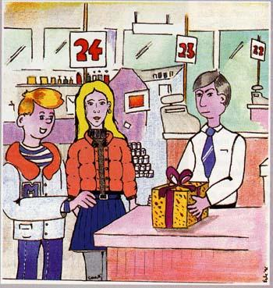

"That's all right," answered Mick. "I'll be there."
"Right then! You've got all the details. Tesco superstore, checkout 24 at 8.50 on Friday. Just say you've come for Mr. Charnwood. They'll give it to you. And don't be late! They shut at nine!"
"And when do I get paid?" asked Mick.
"You'll get fifty quid at the hotel."
Mick put down the phone; he was glad that someone had noticed the small advert he had put in the shop window, offering to do odd jobs. He needed the pocket money.
Sophie was not terribly excited when he told her about it.
"But you said we'd go out to the pictures on Friday night!"
"There's nothing on this week," he replied. "And anyway, I could do with fifty quid. You can come too, it'll be a sort of night out!"
"Oh brill! A trip to Tesco's? You call that a night out? "
"And fifty quid too! It's money for jam!."
"Are you sure it's legal? Why didn't he get Tesco's to deliver it?"
"'Cos they shut at nine, I s'pose. That's fairly obvious, isn't it?"
"Oh well, if you've said you'll do it, you'll have to, won't you?"
"Of course. And anyway, if we get fifty quid, we can go for a pizza at Gigi's afterwards."
"Oh yes, let's!"
It was dark when they got to the superstore; inside, the day's last few shoppers were pushing laden trolleys towards the exits. Checkout 24 was closed.
"Ask someone where it is!" said Sophie.
"Keep cool!" Mick replied in an irritated tone. "What do I ask?"
"Ask where the box is!"
The girl on checkout 12 had no idea what he was talking about.
"I guess we just wait here," said Mick.
They waited.
"Hello," said a voice.
Mick and Sophie, who had been looking into the middle of the shop, turned round. A young man in a white shirt was there, carrying a large box, wrapped up in colored paper.
"Are you looking for something?"
"Yeah!" said Mick. "Is that the box for Mr. Charnwood?"
"Yes. You'll be careful with it, won't you. It's rather fragile. Don't drop it!"
"Thanks!" said Mick.
"My pleasure," said the man. "It's all yours!" And he turned and walked away down the shop.
"Maybe it's champagne!" said Sophie, as they walked across the almost empty car park. "Shall we have a look?"
"Come off it! You can't undo all that wrapping paper! "
As they walked towards the bus stop, the rain began to fall. A bus was approaching. "Come on," said Mick. "That may be ours! Let's run!"
It was not.
"What a waste of effort!" said Sophie, pushing the damp hair out of her eyes. "If we've missed it, we've got half an hour to wait."
But at that moment, the lights of another bus came into view, moving slowly towards them.
"Come on it's a 34!" said Mick. "That'll do!"
The top deck of the bus was empty. They sat down in the seats at the front, and looked out onto the wet street ahead of them.
The pavements, so busy with life during the day time, were more or less empty. Outside a kebab shop, a group of teenagers stood in the shelter of the building, their backs illuminated by the bright lights shining through the window; but the brightly lit windows of most other shops were showing their contents to no-one but a few passengers in passing vehicles.
After the bus turned left into London St, the pavements got darker as shops gave way to houses, their curtained windows hiding private worlds from the inquisitive looks of passers-by. There was less traffic too.
On Parton Hill, the bus got stuck behind a heavy lorry. Then, at Opie's Corner, the traffic came to a stop.
"Hey! What's going on there, I wonder?" said Mick.
In front of them at least three police cars were stopped at the roadside, and another was in the middle of the road. Their flashing blue and red lights lit up a group of people standing in the wet, and apparently looking at something on the pavement in front of a shop.
"Look! It's a man!" said Sophie.
"I expect he's drunk!" said Mick. "That's the shop where I had my ad!"
"Get away!" answered Sophie: "They don't call out four police cars with flashing lights just for a drunk."

Active Vocabulary:
to put down the phone, a shop window, odd jobs, pocket money, to deliver.

Translate into English:
"Але ж ти казав, що в п'ятницю ввечері ми підемо в кіно!"
"На цьому тижні нічого немає", - відповів він. "І взагалі, мені б не завадило п'ятдесят фунтів. Ти теж можеш піти, це буде щось на кшталт нічного відпочинку!"
"О, чудово! Похід до «Теско»? Ти називаєш це вечіркою?» «І п'ятдесят фунтів теж. "
"І п'ятдесят фунтів теж! Це ж гроші на джем!"
"Ти впевнений, що це законно? Чому він не попросив Теско доставити його?"
"Тому що вони зачиняються о дев'ятій, я гадаю. Це ж очевидно, хіба ні?"
"Ну, якщо ти сказав, що зробиш це, то зробиш, чи не так?"
"Звісно. І взагалі, якщо ми отримаємо п'ятдесят фунтів, ми можемо піти на піцу до Джіджі після цього".
Issues for discussion:
a) Have you ever been unable to pay your debts?
b) Do you have a bank account? Where do you keep your money?
c) What do you think the following saying means: time is money?

Навчальне видання

НАВЧАЛЬНИЙ ПОСІБНИК З ПРАКТИЧНОГО КУРСУ АНГЛІЙСЬКОЇ МОВИ

Для здобувачів вищої освіти 1 курсу магістратури

Автори-упорядники МИХАЙЛОВА Людмила Віліївна
МОВЧАН Оксана Олексіївна

В авторській редакції
Комп'ютерний набір Л. В. Михайлова

Видавництво
Народної української академії
Свідоцтво № 1153 від 16.12.2002

Надруковано у видавництві
Народної української академії
Україна, 61000, Харків, МСП, вул. Майка Йогансена, 27.

